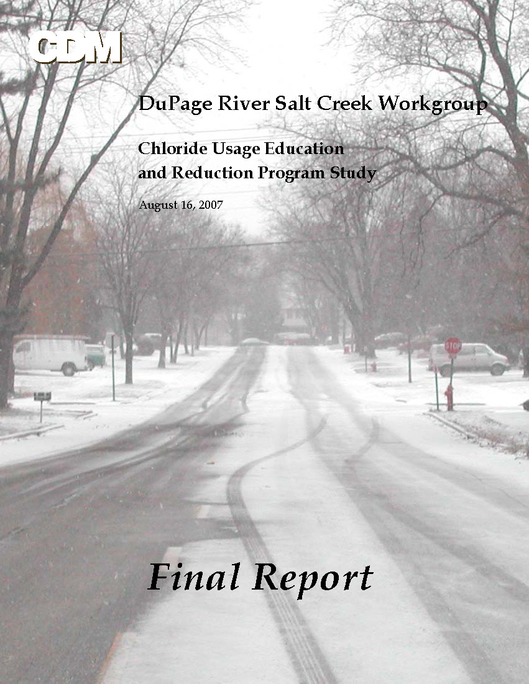
Executive Summary
This Chloride Usage Education and Reduction Program Study addresses the quantity of chloride applied in the watersheds of Salt Creek and the East and West Branches of DuPage River. These watersheds are located in northeastern Illinois, centered in DuPage County. Portions of the watersheds also extend into Cook, Will and Kane Counties.
The study is motivated by recent limitations to the allocated total maximum daily load (TMDL) of chloride in the respective watersheds. In October 2004 the United States Environmental Protection Agency (USEPA) approved chloride TMDLs for Salt Creek and the East and West Branches of DuPage River (IEPA, 2004). The TMDLs call for reductions in chloride loading, specifically from winter road salt application in the watersheds.
In response to the TMDLs adopted for their watersheds, a group of communities, environmental organizations, publicly owned treatment works and other concerned parties came together to form the DuPage River Salt Creek Workgroup (DRSCW). The DRSCW appointed a Chloride Subcommittee, under whose direction this study was initiated to evaluate current road salting practices and to recommend alternative practices for the reduction of chloride loading to the watersheds, to help comply with the chloride TMDLs.
To determine current road salting practices in the watersheds, a questionnaire was sent to about 80 deicing agencies. Responses were received from 39 agencies, who reported a total annual salt use of 126,000 tons. Additionally, eight of approximately 130 private snow removal companies in the watershed area were contacted. Their typical annual salt use ranges from 7.5 to 500 tons per winter.
The total amount of chloride applied to the watersheds annually, in the form of road salt, was estimated from the questionnaire responses. The estimated load includes salt from municipalities, townships, the Illinois State Toll Highway Authority, and county transportation departments; private snow removal companies and the Illinois Department of Transportation are not accounted for. The estimated load is presented in Table ES-1.
Table ES-1: Estimated Current Chloride Load in Study Area
 | Salt Creek | East Branch | West Branch | Total
Estimated Current Load,  tons of Cl⁻/yr | 32,600 | 16,900 | 21,200 | 70,700

A literature search was conducted for this study that revealed a variety of potential measures that could reduce chloride loading to the watersheds. The measures were evaluated for feasibility and potential effectiveness in reducing chloride, and discussed with local deicing program managers for implementation. As a result of this study, the following measures to reduce chloride loading from deicing practices are recommended:
- Public education, staff training, and improved salt storage and handling practices.
- Watershed-wide implementation of pre-wetting and anti-icing programs.
- Consideration of alternative non-chloride products such as acetate deicers and beet and corn derivatives.
- Chloride monitoring in streams to demonstrate program effectiveness.
Several measures to reduce chloride loading were considered but are not being recommended for implementation. These include the use of sand instead of salt, the use of portable snow melting machines, and reduction in the level of service provided by winter road maintenance. For further details refer to the body of the report.
The overall expected reduction in chloride loading to the watersheds as a result of the recommended measures could range from 10 to 40% depending on the level of implementation. A 40% reduction in chloride loadings from deicing activities may not be enough to achieve the TMDL target reductions; other sources of chloride may need to be addressed.
The work plan for the second phase of the Chloride Usage Education and Reduction Program Study may include the following elements:
- Staff training, public outreach and education
- Improved implementation of pre-wetting
- Improved implementation of anti-icing
Capital investment will be necessary to implement new deicing measures or modify existing programs. These investments should result in improved deicing practices that maintain levels of safety and reduce salt (chloride) usage. The resulting reductions in salt needed for deicing will reduce purchase quantities and costs, providing a return on the capital and incentives for implementation. The return period will vary depending upon individual improvements and salt reductions achieved.
Table of Contents
Executive Summary ES-1
Section 1 Introduction 1-1
Section 2 Information Review 2-1
2.1 Applicable Regulations and Guidelines 2-1
2.2 Significant Sources of Chloride 2-2
2.3 Storage and Handling Practices for Salt 2-3
2.4 Application Practices for Salt 2-5
2.5 Alternative Snowfighting Methods 2-6
2.5.1 Mechanical Methods 2-6
2.5.2 Chemical Methods 2-7
2.5.3 Thermal Method 2-10
2.5.4 Instrumentation and Data Collection 2-11
2.6 Deicing Questionnaire Summary 2-12
2.6.1 Snow Removal Policy 2-12
2.6.2 Anti-Icing and Deicing Methods 2-12
2.6.3 Deicing and Snow Removal Equipment 2-13
2.6.4 Salt Storage 2-13
2.6.5 Equipment Maintenance 2-13
2.6.6 Management and Record-Keeping 2-13
2.6.7 Participation in a Potential Pilot Study 2-14
2.7 Private Snowplowing Business Practices 2-14
Section 3 Analysis of Alternatives 3-1
3.1 Baseline Condition 3-1
3.2 Potential Strategies to Reduce Chloride 3-3
Section 4 Recommended Measures 4-1
4.1 Public Education and Staff Training 4-1
4.2 Salt Storage and Handling 4-2
4.3 Alternative Application Methods 4-2
4.3.1 Pre-wetting 4-2
4.3.2 Anti-icing 4-3
4.4 Alternative Products 4-3
4.5 Monitoring to Demonstrate Program Effectiveness 4-3
4.6 Prioritization of Recommendations 4-4
4.7 Potential Sources of Funding 4-4
Section 5 References 5-1

Tables

Table ES-1: Estimated Current Chloride Load in Study Area 1
Table 2-1: TMDL Chloride Allocations for Point and Non-Point Sources 2-3
Table 2-2: Chemical Anti-Icing and Deicing Products 2-9
Table 3-1: Estimated Current Chloride Loading from Road Salt in the
Study Area, Compared with TMDL Road Salt Chloride Allocations 3-3

Introduction
This Chloride Usage Education and Reduction Program Study addresses the quantity of chloride applied in the watersheds of Salt Creek and the East and West Branches of DuPage River. These watersheds are located in northeastern Illinois, centered in DuPage County. Portions of the watersheds also extend into Cook, Will and Kane Counties (see Figure 1-1).
The study is motivated by recent limitations in the allocated total maximum daily load (TMDL) of chloride to the respective watersheds. In October 2004 the United States Environmental Protection Agency (USEPA) approved chloride TMDLs for Salt Creek and the East and West Branches of DuPage River (IEPA, 2004). The TMDLs call for reductions in chloride loading, specifically from winter road salt application in the watersheds.
In response to the TMDLs adopted for their watersheds, a group of communities, environmental organizations, publicly owned treatment works and other concerned parties came together to form the DuPage River Salt Creek Workgroup (DRSCW). The DRSCW appointed a Chloride Subcommittee, under whose direction this study was initiated to evaluate current road salting practices and to recommend alternative practices for the reduction of chloride loading to the watersheds, to help comply with the chloride TMDLs.
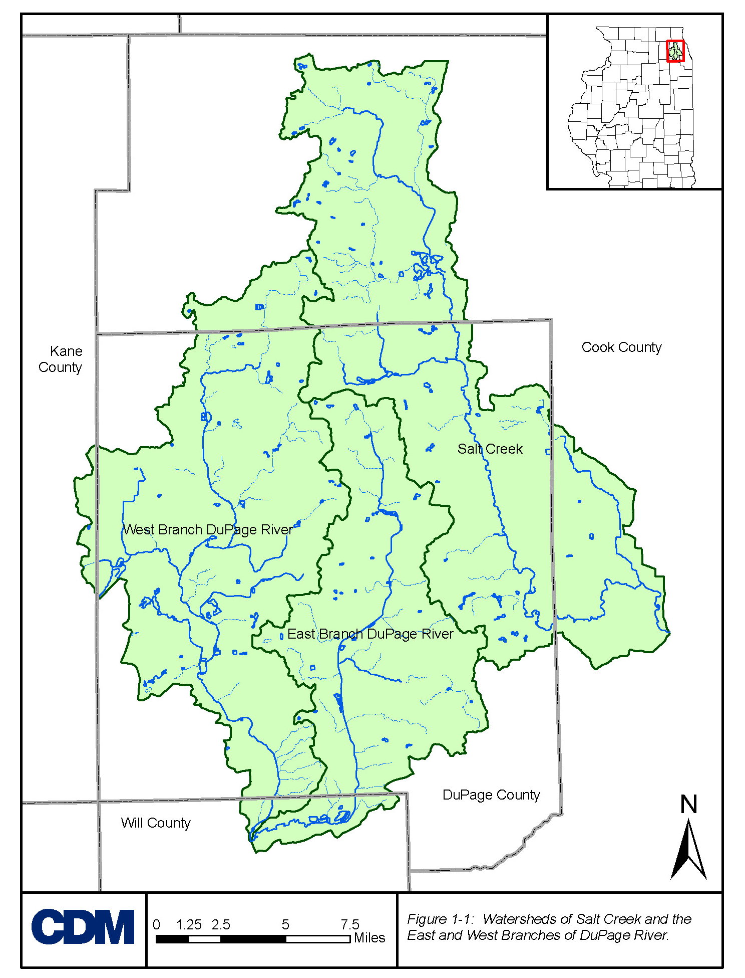

Information Review
An information review was performed to obtain as much information as possible related to applicable regulations and guidelines, and road salting practices and their chloride contributions. The search for information was accomplished via a literature review, a questionnaire, and telephone surveys. This section summarizes the studies, articles, and brochures that relate to road salting regulations and practices in the DuPage River and Salt Creek watersheds, and available alternatives to existing practices that could result in reduced chloride loadings. The questionnaire was distributed to municipalities and agencies in the watersheds to obtain information related to their deicing practices. This information, as well as information gathered by other telephone surveys, is presented below, following a summary of the applicable regulations and guidelines.
2.1 Applicable Regulations and Guidelines
Chloride is an ionic form of the element chlorine, is found in many common salts, and is readily soluble. In its dissolved form, it does not degrade chemically or organically over time. Chloride should not be confused with chlorine, a soluble substance often used as a disinfectant. Reverse osmosis and distillation are potential methods of removing chloride from water.
Chloride has not always been viewed as a pollutant or contaminant of water. It is an essential part of the diet of humans and other animals, and the oceans have a normal, healthy, chloride concentration of about 21,000 mg/L. However, elevated concentrations of chloride in fresh water can threaten aquatic life as well as introducing a salty taste to sources of drinking water. The US Public Health Service and Health Canada both set the secondary drinking water chloride standard at 250 mg/L, and the US Public Health Service further recommends an ideal limit of 25 mg/L (Mangold, 2000).
The impact of chloride on aquatic life varies from species to species. In 1988 the USEPA conducted a broad literature search and established water quality criteria for chloride to protect aquatic life (USEPA, 1988). Data of sufficient quality were available to evaluate response (impacts) for three species: cladoceran (daphnia pulex), rainbow trout and fathead minnow. The published conclusion was that the four-day average and one-hour average chloride concentrations should not exceed 230 and 860 mg/L, respectively, if fresh water aquatic organisms and their uses are to be protected.
In 1972 the Illinois Pollution Control Board (IPCB) adopted a general use chloride water quality standard (WQS) of 500 mg/L. This standard lies between the acute and chronic chloride limits established by USEPA. Salt Creek and the East and West Branches of DuPage River are designated for general use; therefore, the 500 mg/L standard applies.
The TMDLs for these watersheds were specifically derived to achieve compliance with the 500 mg/L standard. In the West Branch watershed, a reduction of 35% is specified for chloride applied in deicing operations, and in the East Branch watershed the reduction is 33% (IEPA, 2004, East and West Branch TMDLs). The Salt Creek TMDL subdivided the watershed between Addison Creek and Salt Creek, which were targeted for 41% and 8% reductions, respectively (IEPA, 2004, Salt Creek TMDL). Throughout this report, the watersheds of Addison Creek and Salt Creek are collectively called “Salt Creek”; the overall Salt Creek reduction is 14%. Additional information on these reductions is provided in the TMDL documents.
2.2 Significant Sources of Chloride
The obvious first step in addressing the chloride levels in Salt Creek and DuPage River is to identify and prioritize the sources of chloride in the watersheds. With this objective, the Illinois Environmental Protection Agency (IEPA) spent considerable effort collecting and reviewing data, and modeling the watersheds.
Water samples were taken from the watersheds over the period from 1995 to 1999. During this time, there were five observed exceedances of the chloride WQS in Salt Creek. In the same period, one exceedance was observed in each of the East and West Branches of the DuPage River. All seven of these exceedances occurred in January, February or March. Furthermore, plots of observed chloride concentrations by month showed clear seasonal variation. In each watershed, the highest chloride concentrations occurred in winter months, while the lowest occurred in summer.
Modeling performed for establishment of the TMDLs included three sources of chloride: the background groundwater concentration, point source discharges and road salting.
- Groundwater provides base flow to the streams. The average groundwater chloride concentrations were 51 and 106 mg/L in the Salt Creek and East Branch watersheds, respectively. (Groundwater is not mentioned in the West Branch TMDL.)
- The range of observed chloride concentrations in point source discharges was 90 to 555 mg/L. These data were collected as part of The Conservation Foundation data collection program (IEPA, 2004, Salt Creek, East Branch and West Branch TMDLs). For modeling, the point source discharges were assigned a constant concentration for each watershed: 300 mg/L in the Salt Creek watershed and 400 mg/L in the East and West Branch watersheds.
- Chloride loading from road salting was based on 14 snowfall events, accounting for the length of road surface in each watershed and assuming a standard salt application rate. For Salt Creek and the East Branch, the rate assumed was 800 lb per lane-mile per storm, a value based on literature from other major cities. For the West Branch, local data from four communities yielded an average rate of 1,300 lb per lane-mile per storm.
The conclusion of the TMDL reports was that “[the] primary contributor to the [chloride WQS] exceedances is application of road salt for snow and ice control purposes. However, due to the sporadic nature of deicing activities, on a yearly basis, the chloride mass contributed to the West Branch DuPage River watershed is larger from point sources than nonpoint sources.” (IEPA, 2004, West Branch TMDL) The conclusions regarding Salt Creek and the East Branch are the same.
Road salt is almost entirely sodium chloride, which is composed of 39.3% sodium and 60.7% chloride, by mass. (An anti-caking agent containing cyanide is usually added to road salt; the cyanide may pose a water quality concern, but is outside the scope of this study.)
In the TMDL reports, the contribution of chloride from non-point sources was calculated directly from “salt applied for deicing purposes, since that is the most direct measurement of chloride applied to the watershed.” (IEPA, 2004, East Branch TMDL) For reference, the chloride TMDL allocations are summarized in Table 2-1.
Table 2-1: TMDL Chloride Allocations for Point and Non-Point Sources
 | Salt Creek | East Branch | West Branch | Total
Point sources,  tons of Cl⁻/yr | 28,700 | 34,100 | 19,300 | 82,100
Non-point sources,  tons of Cl⁻/yr | 13,300 | 5,200 | 13,700 | 32,200
Source: IEPA, 2004, Salt Creek, East Branch and West Branch TMDLs.

As of June 7, 2007, questionnaire responses were received from 39 municipalities and agencies who reported a total annual salt use of 126,000 tons. Approximately 88,000 tons of this salt (53,000 tons of chloride) are applied within the boundaries of the East and West Branch and Salt Creek watersheds. The responses represent approximately 69% of the total watershed area.
Additionally, 8 out of approximately 130 private snow removal companies in the watershed area were contacted and interviewed. The typical annual salt use of these companies ranges from 7.5 to 500 tons per winter (4.5 to 300 tons of chloride per winter).
An informal look at the quantity of salt used by residential homes was conducted as part of this study. Sales quantities were obtained from retail suppliers in a typical area community with a population of approximately 20,000. Total of annual salt sales for driveway deicing and water softener use is estimated at over 250 tons per year for the typical community. This figure is a rough estimation and more detailed study should be performed for any meaningful calculations.
2.3 Storage and Handling Practices for Salt
The Salt Institute has published a Salt Storage Handbook (Salt Institute, 2006) with recommended practices and design guidelines for salt storage facilities. Also, the Transportation Association of Canada (TAC) has published detailed best management practices (BMPs) for road salt storage (TAC, 2003) and a training manual for salt program managers and staff (TAC, 2005). The key measures presented in these documents are listed below. Results from the deicing questionnaire that describe how these BMPs are implemented locally are included where appropriate:
- The site should be located down gradient of any water supply wells.
- Drainage from the site should not enter any water body or fresh water supply, and should be properly controlled and contained. Drainage is controlled or collected by about half of the questionnaire respondents. Two questionnaire respondents have storage sites within 100 feet of a water body, and fifteen more have sites within 1,000 feet.
- Salt should be stored on impermeable pads that slope away from their centers at about ¼ inch per foot (2%). Five questionnaire respondents do not store their salt on impermeable pads.
- Salt stockpiles should be protected with structural roofs or temporary covers. All but one of the questionnaire respondents keep their salt in a storage structure.
- Areas used for loading and handling salt should be protected from precipitation and wind. Thirteen questionnaire respondents said their salt is exposed or partially exposed to the elements, and only seven said their loading areas are completely covered.
- Salt should be handled as little as possible, to avoid particle breakdown and loss of material. Care should be taken to minimize spillage and clean up spilled salt.
- Frozen or clumped blocks of salt should be either set aside to be dried and crushed, or added to brine tanks.
- Preferably, vehicles should be washed indoors to contain the wash water. Wash water should be put through an oil and grit separator, and either added to brine tanks or disposed of properly. All but three questionnaire respondents wash their vehicles indoors.
- Liquid storage facilities require further considerations such as secondary containment, protection from freezing, protection from vehicle impacts, backup power supplies, reuse of wash water, etc. Twenty-eight questionnaire respondents mentioned having tanks for liquid deicing chemicals.
The costs associated with poorly managed sites can be considerable. Environment Canada has published a case study from Heffley Creek, a small community in British Columbia, Canada (Environment Canada, 2004, “Remediation vs. Salt Storage…”). In 1993, Heffley Creek residents complained of a salty taste in their water, and investigations revealed that leakage from the local salt storage site had contaminated the groundwater. In the following ten years, the Province of British Columbia incurred over $2 million in remediation costs, including site remediation, replacement of drinking water sources and claims from local residents for property damage. The population of Heffley Creek is around 700.
2.4 Application Practices for Salt
Salt has been used to control snow and ice on U.S. streets since the 1800s (Cheshire, 2006). From the time of its first use there have been complaints about its effects: it made sleighing impossible and also damaged footwear and clothing. Although it still has undesirable effects, most notoriously corrosion, it is now the most popular deicing material in North American cities.
In response to concerns about its effects on infrastructure and the environment, several guidelines and recommendations for salt application have been published. The Salt Institute has produced a handbook for snowfighters (1999) and an online snowfighters training program (2000); TAC published the Salt SMART Learning Guide, offering best management practices for Spreading, Maintenance, Application Rates & Timing (SMART) of road salt (TAC, 2005); and Minnesota’s Department of Transportation (MN/DOT) published a handbook for snowplow operators (MN/DOT, 2005). A few key recommendations from these documents are listed below. Results from the deicing questionnaire that describe how these practices are implemented locally are included where appropriate:
- A clear level of service (LOS) should be established for each route or area, based on usage levels or regulation. This LOS should be communicated to staff and to the public.
- Staff should be trained in proper spreading procedures, record-keeping and the environmental impact of their work. Operators are trained annually (or more often) by 32 of 39 questionnaire respondents.
- Equipment should be maintained and inspected before and during the snow season, with spare parts available at all times.
- Spreader routes should be optimized to eliminate leftover salt and “dead-heading” (driving without spreading).
- The spreaders should be covered to prevent loss of salt in wind and precipitation.
- The spreaders should be equipped with instrumentation to monitor current conditions and salt usage.
- Spreading equipment should be calibrated regularly and records should be kept of salt use in each truck and each route. Actual usage should be compared against the prescribed spreading rates to catch over-use and inefficiencies. Weigh-scales on the spreading equipment and at the entrance to the storage area make record-keeping simple. Salt usage records for each truck are kept by 22 questionnaire respondents.
- Spreading rates should be based on the best available information, including the current road conditions, LOS and weather forecast. Communication with operators should be clear.
Implementing best management practices can lead to considerable cost savings and chloride reduction. The City of Toronto, for example, spent about $100,000 on staff training, fleet instrumentation and a salt management plan. As a result, their annual salt use was reduced by 25% over two winter periods, translating into annual savings of about $1,800,000 (Environment Canada, 2004, “City of Toronto…”). In Quebec, the Town of Otterburn Park reduced their salt use by a factor of six, between 1995 and 2000, by training staff, improving plowing practices, revising the LOS policy and pre-wetting salt (Environment Canada, 2004, “Salt Reductions…”). Their benefit-to-cost ratio for was 2.8:1 for the changes that were implemented.
2.5 Alternative Snowfighting Methods
Spreading granular salt is not the only way to control snow and ice accumulations on roadways. The earliest human technique was plain manual effort. Manual efforts were subsequently replaced and supplemented with hand-tools, powered machines, fire and chemical agents. This section presents the methods, other than granular salting, currently used in the North American snow belt.
2.5.1 Mechanical Methods
Plowing snow off the roads is standard practice in almost every city. It is good practice to plow just before salting or to add a plow blade to a salt-spreading vehicle so that the salt is applied to a bare or near-bare surface. Otherwise salt can be wasted by melting heavy snow, or can be plowed off the roadway before it reaches the road surface (TAC, 2005).
If enough snow accumulates between melting events, the mounds of snow at the sides of roadways can inhibit continued plowing efforts. If this occurs, one alternative is to transport the snow to a disposal facility where it can be piled or dumped. Since the plowed snow carries salt, grit, oils and other pollutants, the snow disposal facility must be engineered to control the release of these contaminants. The City of Ottawa, Canada, has an average annual snowfall of 7.7 feet and disposes over 2,000,000 yd³ of snow each winter, on average. To manage the logistical, fiscal and environmental challenges, they are now implementing a snow disposal program that includes phasing out unacceptable disposal sites, upgrading old sites and designing and constructing new ones. (Environment Canada, 2004, “Engineered Snow Disposal…”)
An old and widely used practice is spreading abrasives, such as sand or cinders, on the roadway. Although abrasives supply some traction for traffic, contain no chlorides, and are more visible than salt, they have many drawbacks (Salt Institute, 1985):
- Abrasives do not break the bond between pavement and ice.
- They can be covered up or mixed with snow and become useless.
- They can reduce traction on road surfaces after the snow and ice are gone.
- They can chip paint and pit windshields.
- They can clog drains and smother roadside vegetation.
- They may require costly cleanup efforts after a storm or storm season.
2.5.2 Chemical Methods
Two important variations on road salting exist: anti-icing and pre-wetting. Here are the definitions used by Environment Canada (2003):
- “Anti-icing is the application of a deicer to the roadway before a frost or snowfall to prevent melted snow and ice from forming a bond with the road surface.”
- “Pre-wetting is the addition of a liquid to solid deicers or abrasives before application to quicken melting and improve material adherence to the road surface.”
Anti-icing is a preventative measure, as deicing agents are applied to roads before snow or ice appears. Clearly, the timing of the application is critical, and anti-icing strategies depend on information systems and forecasting of road conditions. A simple anti-icing program is the application of salt brine to the roads when a storm is forecasted. The brine may or may not dry before the storm comes, but as soon as snow falls or frost begins to form the brine will activate and prevent a bond forming between the ice and the pavement.
Anti-icing is becoming widely accepted and offers many advantages, including cost and material savings, improved level of service, and reduction in accidents. A further environmental benefit is that liquid anti-icing brines do not contain the cyanide anti-caking agent commonly added to road salt (Mangold, 2000).
The MN/DOT Field Handbook reports that anti-icing uses about 25% of the material at a tenth of the cost of conventional deicing (MN/DOT, 2005); this is supported by the experience of the McHenry County Division of Transportation (Devries, 2007).
A thorough review of cost savings and other benefits achieved through anti-icing is given by O’Keefe and Shi (2005). Colorado saw an overall cost savings of 52% after implementing anti-icing, while Oregon realized cost savings of 75% for freezing rain events. In Montana, anti-icing reduced sand use by 41%, and overall Montana saved 37% in costs per lane mile with anti-icing, including costs for labor, equipment, and materials. Reductions in the rate of accidents range from 8% to 83%, and result in significant cost avoidance (O’Keefe and Shi, 2005).
The Michigan Department of Transportation conducted anti-icing trials along US-31 over the winter of 1999-2000. Anti-icing was performed on the test section with M50 liquid deicer (see table below), while the control section was deiced with rock salt alone. The test section and the control section were each 32 lane-miles. On the control section 536 tons of rock salt were used, while on the test section 325 tons of rock salt and 6450 gallons of anti-icing liquid were used. The reduction in rock salt alone was therefore 39%; however, taking into account the chloride in the anti-icing liquid, the reduction in chloride was 38% (Kahl, 2002).
One objection to anti-icing is that it necessitates a change in operational strategy by having trucks on the roads before a storm rather than during or after. The City of Chicago, for example, found the change in operations difficult during an anti-icing trial (Keating, 2001). The U. S. Department of Transportation (USDOT, 1996) has published a manual to help managers implement anti-icing programs.
In a few instances, anti-icing has been reported to cause some slipperiness on the roads. However, slipperiness can be caused by other contaminants on the road, and may be attributable to driver perception; professionals in the field unanimously agree that anti-icing improves public safety (O’Keefe and Shi, 2005).
Anti-icing agents are most commonly liquids, but can also be pre-wetted solids. A variety of anti-icing and deicing agents is presented in Table 2-2.
Pre-wetting is a variation on the usual practice of spreading solid salt and/or abrasives during a storm event, and does not require a significant change in snowfighting strategy. The Wisconsin Transportation Information Center (WTIC, 2005) and others (Mangold, 2000; MN/DOT, 2005) report that a conventional application of dry salt wastes about 30% of the material due to wind- and traffic-induced scatter. This waste can be reduced to only 4% by pre-wetting the material before spreading it (WTIC, 2005; TAC, 2005). Materials savings due to pre-wetting have been found as high as 53% (O’Keefe and Shi, 2005). Pre-wetted salt also acts more quickly than dry salt because there is no delay waiting for a brine to form. The liquid pre-wetting agent is applied at a rate of approximately 10 gallons per ton of dry salt (Wisconsin Transportation Information Center, 2005), which is equivalent to 20-30 lb of dry salt added per ton.
A drawback of pre-wetting is the cost of equipment modification for onboard pre-wetting capability. However, MN/DOT (2005) points out that pre-treatment can be used instead of pre-wetting. Pre-treatment involves mixing a liquid deicer with the salt stockpile before it is loaded into spreader trucks. This precludes the need for equipment modifications.
Environment Canada reported four case studies in which anti-icing and pre-wetting played a role in cost and material savings in winter road maintenance:
- Cypress Bowl, a ski area in British Columbia, achieved a cost savings of 34% through anti-icing, pre-wetting and training, and their chloride usage was reduced by 73% (Environment Canada, 2004, “Implementation of Anti-Icing…”).
- The Town of Otterburn Park, Quebec, reduced their salt use by a factor of six by implementing better practices including pre-wetting (Environment Canada, 2004, “Salt Reductions…”).
- The City of Kamloops introduced anti-icing and pre-wetting and achieved reductions in wintertime accidents, snow and ice control costs, and abrasives (Environment Canada, 2004, “Winter Maintenance Innovations…”).
- A 10% salt reduction was achieved in Brooklyn, Nova Scotia, through pre-wetting alone (Environment Canada, 2004, “Utilizing Technological Advances…”).
Table 2-2 summarizes various chemical products available as anti-icing and deicing agents. Information was obtained from Keating (2001), Caraco and Claytor (1997), the MDSS consortium (2006), Fischel (2001) and product manufacturers’ websites. For a comprehensive literature review and comparative analysis of several chloride- and acetate-based deicers, see Fischel (2001).
Table 2-2: Chemical Anti-Icing and Deicing Products
Product | Estimated  Cost¹ | Cl⁻ by mass | Eutectic Temperature² | Other Characteristics
Rock salt (NaCl) | $20-40 / ton  or $0.03-0.10 / gal | 61% | -6°F | Very corrosive; harmful to vegetation; can attract wildlife
Calcium chloride (CaCl₂) | $200-340 / ton | 64% | -60°F | Extremely corrosive; exothermic melting; dissolves in atmospheric moisture; harmful to vegetation
Magnesium chloride (MgCl₂) | $260-780 / ton | 75% | -27°F | Corrosive; can attack concrete
Potassium Chloride (KCl) | $240 / ton | 48% | 12°F | Corrosive
Calcium magnesium acetate (CMA) | $650-2000 / ton | 0% | -18°F | Low toxicity; non-corrosive; can cause O₂ depletion
Potassium acetate (CF7®) | $2.60-3.90 / gal or $600 / ton | 0% | -76°F | Non-corrosive; can cause O₂ depletion
Urea | $280 / ton | 0% | +10°F | Endothermic; degrades to ammonia, then nitrate; working temperature same as CMA
Ice Slicer® | $58-64 / ton | Some | -6°F | Granular and reddish, with naturally occurring complex chlorides (Mg, Ca, Na and K chlorides); 20-70% less corrosive than rock salt; harmful to vegetation
CG-90® Surface Saver® | $185-250 / ton | 63% | -5°F | Handles like road salt; 76% NaCl, 22% MgCl₂ plus corrosion-inhibitor
Caliber® M1000 | $0.55-1.50 / gal | 23% | -86°F | Corn derivative liquid deicer plus 30% MgCl₂; corrosion inhibitor; can cause O₂ depletion
GEOMELT® 55 | $1.25-1.90 / gal | 0% | -44°F | Organic anti-icer/ deicer; 4x less corrosive than water; can be mixed with brines or solid salts
M50 (Ice Ban®, Magic Minus Zero®) | $0.70-0.85 / gal | 11% | -78°F | Organic deicer plus MgCl₂ solution (15% MgCl₂ by weight); less corrosive than water; oxygen demand equivalent to CMA; pH < 4.0
MagicSalt® | 1.4 times rock salt | 61% |  | Rock salt treated with M50; effective down to -35°F; use 30 to 50% less than plain rock salt
¹ The estimated material costs were based on the references cited above as well as a web search of product sales. The costs may vary regionally and with time.

² The eutectic temperature is the lowest temperature at which the deicing agent can remain in liquid form. The minimum working temperature is loosely defined and tends to be higher; for example, rock salt’s eutectic temperature is -6°F, but its minimum working temperature is approximately 16 to 20°F.

Some of the deicing products listed in Table 2-2 contain little or no chloride, but introduce concerns with biochemical oxygen demand (BOD) in receiving waters. These include the acetate products as well as the organic process derivatives.
Responses to the questionnaire indicated that most agencies in the watersheds are using rock salt pre-wetted with calcium chloride. Two agencies use sand, three use magnesium chloride, four use CMA, two use potassium acetate, and one uses GEOMELT® 55.
The Pacific Northwest Snowfighters (PNS) Association has developed standards for deicing chemicals, and publishes a list of approved substances on its website (PNS, 2006).
2.5.3 Thermal Method
Stationary snow melting machines are used in some municipalities, including New York, as an alternative to hauling snow long distances to disposal sites. New York has 20 diesel-fueled snow melting machines, each capable of melting 60 tons of snow per hour. Sanitation Commissioner John Doherty said the machines cost approximately $200,000 each (Barry, 2006), not including fuel and maintenance costs. The City of Naperville rented a stationary snow melting machine over the 2006-2007 winter season to reduce hauling costs.
The City of Toronto uses five portable snow melting machines as part of its winter road maintenance. These vehicles lift snow into a heated onboard tank where the snow is melted at a rate of 150 tons per hour. The melted snow is subsequently discharged into street-side storm drains. According to Gary Welsh, Toronto’s Director of Transportation Services, the machines cost approximately $1 million each (Keating, 2001).
Stationary or portable melting machines have been used to address snow quantity issues, but with respect to reducing chloride loadings, they are not highly effective as an alternative to traditional deicing practices.
2.5.4 Instrumentation and Data Collection
While information systems are not an “alternative method of deicing,” they work together with other snowfighting practices by informing agencies’ decisions on winter maintenance and improving the effectiveness of deicing practices. The systems in North America range from elementary to advanced, and include the following:
- Load scales at storage facilities and in spreader trucks
- Benchmarking of salt usage on municipal routes
- Maintaining records of salt use by route, by storm and by winter
- Ground speed sensors and digital spreaders on salt trucks
- Real-time salt application monitoring with Automated Vehicle Location systems
- Pavement temperature sensors on trucks and in-ground installations
- Regional and local weather forecasts
- Road condition monitoring and forecasting, including networks of monitoring stations called Road Weather Information Systems (RWIS)
Two of Environment Canada’s case studies describe implementation of advanced systems. In Nova Scotia, 19 RWIS stations had been installed by January 2004. The RWIS is allowing the Department of Transportation and Public Works to take a proactive approach to winter road maintenance, and together with pre-wetting practices, has led to a reduction in salt usage (Environment Canada, 2004, “Utilizing Technological Advances…”).
The Ministry of Transportation of Ontario recognized the interchange ramp of Highway 401/416 as an accident-prone point in winter. In response, they installed RWIS and Fixed Automated Spray Technology (FAST), which automatically applied deicer to the ramp when conditions warranted. No further winter-related accidents have occurred at that location (Environment Canada, 2004, “Accident Reduction…”).
Illinois has a state-wide network of 51 RWIS stations, which save the state millions of dollars each year in snow removal costs (Dameron, 2004).
2.6 Deicing Questionnaire Summary
In November 2006 and April 2007, the DRSCW distributed a questionnaire to about 80 municipalities and public works agencies. The purpose of the questionnaire was to obtain baseline information about the current deicing practices throughout the DuPage River and Salt Creek watersheds. The questionnaire asked for information about deicing practices and strategies under the following categories:
- Snow removal policy
- Anti-icing and deicing methods
- Deicing and snow removal equipment
- Salt storage
- Equipment maintenance
- Management and record-keeping
- Participation in a potential pilot study
As of June 7, 2007, 39 responses had been received. The following sections summarize the responses in each of the above categories. A blank questionnaire and all responses are included on the CD accompanying this report (Appendix A).
2.6.1 Snow Removal Policy
The questionnaire asked for the agency’s snow removal policy and the length of roadway served. All 39 agencies provided policies. Most snow removal policies are based on achieving bare pavement within a certain amount of time following the end of the storm; the time allowances vary from 4 to 24 hours. In some cases, primary roadways are prioritized. The length of roadway served varies between 55 and 1,400 lane-miles, and the total of all the responses is approximately 10,000 lane-miles.
2.6.2 Anti-Icing and Deicing Methods
The second section of the questionnaire asked whether agencies used anti-icing, and what substances or products they employed for anti-icing and deicing. Out of the 39 respondents, 14 mentioned anti-icing practices; in most cases the anti-icing program is limited to occasional pre-salting or liquid spreading in priority locations. For deicing agents, 38 agencies use solid rock salt and 34 use liquid calcium chloride. Five agencies use salt brine (NaCl). Calcium magnesium acetate (CMA) is used by four agencies. Abrasives, liquid magnesium chloride and liquid potassium acetate are each used by two agencies. One agency uses an agricultural deicing product.
Pre-wetting is practiced by approximately 29 agencies. This figure was inferred from whether the agencies either use pre-wetted materials or own equipment for spreading pre-wetted solids.
2.6.3 Deicing and Snow Removal Equipment
The third section asked what equipment was used for deicing and snow removal efforts. Snow plows were reported in use by 34 agencies, and the remaining agencies are also assumed to use snow plows. Mechanically-controlled and computer-controlled spreaders for deicing agents are both widely used: 32 agencies have mechanically-controlled equipment and 23 have computer-controlled. Equipment for spreading liquids is used by 15 agencies. End loaders and bobcats were frequently mentioned on the “Other” line.
2.6.4 Salt Storage
The next section asked for some basic information about how salt was stored. Out of the 38 agencies using salt:
- 33 store salt on an impervious pad;
- 37 keep the salt in a “storage structure”;
- 25 said their salt is not exposed at all to the elements;
- 15 said drainage from their storage area(s) is controlled or collected; and
- 7 said their loading area(s) are covered or contained.
The number of storage areas owned and maintained by each agency ranges from 1 to 3, with the majority having just one. Seventeen of the agencies store salt within 1,000 ft of the nearest water body, and two agencies store it within 100 ft.
2.6.5 Equipment Maintenance
The next section asked how the snowfighting equipment was washed. For 36 agencies the equipment is washed at an indoor station draining to the sanitary sewer. Three agencies wash equipment outside where the water can drain to a sanitary sewer, and five mentioned outdoor washing in areas not drained to a sanitary sewer.
2.6.6 Management and Record-Keeping
The sixth section asked for information about the management of the deicing programs. Operators are trained annually (or more often) in 32 agencies. Four of the remaining agencies train at the start of employment, and the other three did not specify a training schedule.
The rate of salt application is established by the director or supervisor in 33 agencies, and by the operators in five agencies. The spreading rate is controlled by the operator in 24 agencies, controlled automatically in 14 agencies and set at a fixed rate in 7 agencies.
Twenty-two agencies keep records of salt usage per truck, twenty-eight keep records for each storm, and twenty-three keep records for each winter. Each agency provided an estimate of the average amount of salt they used per winter; the total of their estimates is 126,000 tons per winter.
2.6.7 Participation in a Potential Pilot Study
The final question asked whether the agency would consider participating in future pilot studies or demonstration projects for alternative deicing equipment or practices. Twenty-three indicated a willingness to participate.
2.7 Private Snowplowing Business Practices
On March 29, 2007, nine municipalities in the study area were contacted to ask about license requirements for private snow plowing businesses. The municipalities were Addison, Bartlett, Bloomingdale, Carol Stream, Downers Grove, Elmhurst, Lisle, Naperville and Palatine. Snow plowing businesses are not required to hold a license anywhere except in Addison and Palatine. Licenses in those municipalities are for the office location only, and do not regulate how deicing practices are conducted.
Between March 30th and April 4th, 2007, eight private snow removal contractors in the study area were contacted. Private contractors tend to serve commercial, industrial and residential customers, clearing parking lots and private drives rather than roads. Based on surveying those contractors, their salt use ranges from 7.5 to 500 tons per winter, and averages approximately one ton per acre of parking lot per winter. Private contractors are not usually required to hold a business license in the area they serve unless they have an office location in the served area. Many of their customers require them to hold insurance. Based on a business search, there are approximately 130 private snow removal services in the study area.

Analysis of Alternatives
3.1 Baseline Condition
The analysis of any alternative practices must begin with a baseline condition. The amount of chloride applied annually to the watersheds for deicing was estimated from the responses to the deicing questionnaire. Since some of the municipalities and agencies who responded lie partly outside the watersheds, a geographical analysis of the data was conducted using Geographic Information Systems (GIS) tools.
The total amount of salt used in the watersheds is different from the total amount reported on the questionnaires, for several reasons. First, some areas within the watershed were not represented by a questionnaire response, but salt is being applied there. Second, some questionnaire responses represent municipalities that apply some of their salt outside the watersheds. The following paragraphs describe the assumptions and calculations involved in estimating the total amount of deicing salt (and chloride) applied annually in the watersheds.
The watersheds are composed of both incorporated and unincorporated areas. The incorporated areas make up 266 of the total 355 square miles of watershed area (approximately 75%). Some municipalities, such as Wheaton, are completely within the watershed boundaries, while others, such as Bartlett, lie partly outside. Forty-five municipalities have at least one square mile of incorporated area within the watersheds, and small corners (less than one square mile) of other municipalities are also included. The remaining 89 square miles of unincorporated area are under the jurisdiction of township authorities.
Municipalities, townships and other agencies were treated separately. The annual salt use of each municipality that returned a questionnaire was plotted against its incorporated area (see Figure 3-1 below). There is a strong correlation between annual salt use and incorporated area (R² = 0.80). The best fit line through those data was used to estimate the annual salt use for each municipality not represented by a questionnaire. For example, one city which did not return a survey has an incorporated area of approximately 13 square miles, so its estimated salt use is approximately 3,500 tons annually. (One outlier was omitted from the statistical analysis, as illustrated in the figure.)
For each municipality, the annual salt use was multiplied by the fraction of incorporated area lying within the watersheds, to estimate the amount of salt applied within the watersheds. For example, 39.6% of Bartlett’s area lies within the watersheds. Bartlett reported an annual salt use of 2,200 tons of salt; therefore, 872 tons (39.6%) was assumed to be used within the watersheds.
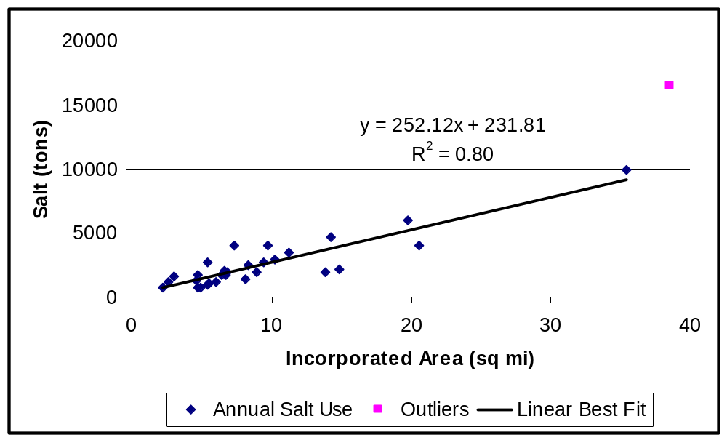
Figure 3-1: Annual salt use by municipalities that responded to the questionnaire. Salt use in other communities was estimated from the best fit line.
Six townships returned questionnaires indicating their typical annual salt use. The average amount of deicing salt applied annually is 1,025 tons. The annual salt use of townships that did not return questionnaires was therefore estimated as the average, 1,025 tons.
It was assumed that townships only apply deicing salt in unincorporated areas. For townships whose unincorporated areas were partly outside the watersheds, the annual salt use figures were reduced using the same method employed with the municipalities. For example, Winfield Township has 20.64 square miles of unincorporated area, of which 88.7% is within the watersheds. Winfield Township reported an annual salt use of 600 tons of salt; therefore, 532 tons (88.7%) was assumed to fall within the watersheds.
In addition to municipalities and townships, three other agencies returned questionnaires: Illinois State Toll Highway Authority (ISTHA), DuPage County Department of Transportation (DuDOT) and the Forest Preserve District of DuPage County.
ISTHA reported using an average of 8,900 tons of salt annually in DuPage County. (ISTHA did not provide averages for other counties.) Since DuPage County and the watersheds mostly overlap, the annual salt contribution to the watersheds from ISTHA was estimated using the ratio of the watershed area to the area of the county (355 to 336 square miles); thus, ISTHA’s estimated contribution was 9,400 tons. In the same way, the 20,000 tons of salt used annually by DuDOT is scaled up to 21,100 tons to be representative of salt applied by county transportation departments across the watersheds. The Forest Preserve District of DuPage County uses no rock salt.
No estimate of salt use was obtained from Illinois Department of Transportation.
The total amount of road salt applied to the watersheds annually is approximately 117,000 tons, taking into account the salt applied by municipalities, townships, ISTHA and DuDOT. The equivalent amount of chloride is 70,700 tons. This total is broken down between Salt Creek and the East and West Branches of DuPage River as shown in Table 3-1 (DRSCW Baseline).
The TMDLs for Salt Creek and the East and West Branches of DuPage River estimated baseline chloride loadings for each watershed by assuming 14 snowfall events per winter and applying a standard salt application rate (IEPA, 2004, Salt Creek, East Branch and West Branch TMDLs). The area of road surface in each watershed was adjusted for expected future development. For Salt Creek and the East Branch, the salting rate assumed was 800 lb per lane-mile per storm, a value based on literature from other major cities. For the West Branch, local data from four communities yielded an average rate of 1,300 lb per lane-mile per storm.
Using a watershed model, the TMDLs calculated the required reductions in chloride for each watershed. The TMDL baseline chloride loadings (TMDL Baseline) and road salt allocations are shown for reference in Table 3-1.
Table 3-1: Estimated Current Chloride Loading from Road Salt in the Study Area, Compared with TMDL Road Salt Chloride Allocations
 | Salt Creek | East Branch | West Branch | Total
DRSCW Baseline,  tons of Cl⁻/yr | 32,600 | 16,900 | 21,200 | 70,700
TMDL Baseline,  Tons of Cl⁻/yr | 15,500 | 7,800 | 21,100 | 44,400
TMDL Target,  tons of Cl⁻/yr | 13,300 | 5,200 | 13,700 | 32,200

3.2 Potential Strategies to Reduce Chloride
There are a variety of potential strategies to reduce the chloride applied as road salt within the East and West Branch of DuPage River watersheds and the Salt Creek watershed. Since the effectiveness of a given strategy is dependent on the specifics of implementation and on the current local practices, the potential reductions in chloride can only be approximately estimated.
In the case study reported by Environment Canada (2004, “City of Toronto…”), salt management planning efforts and staff training led to a 25% savings in annual salt use. Such large savings just through planning and training may or may not be repeatable in the DuPage and Salt Creek watersheds; however, for the purposes of this study it is assumed that staff training and improved storage and handling practices may lead to a chloride savings of up to 10%.
Alternative products can be very effective in reducing chloride application. Acetate-based deicers, such as calcium magnesium acetate, contain no chloride; therefore, the potential chloride savings is 100% if deicing is done entirely with these products. Organic deicers, such as those based on corn and beet derivatives, also contain no chlorides. They are typically mixed with liquid chlorides for anti-icing and pre-wetting use, but have improved performance as compared to liquid chlorides alone (Devries, 2007).
As described in Section 2, pre-wetting generally reduces the amount of salt applied by approximately 30%. Based on the questionnaire responses, approximately 74% of agencies in the watersheds are currently pre-wetting their salt. If the remaining 26% of agencies also implement pre-wetting practices, a savings of 5,400 tons may be achieved (8%).
The reported savings from anti-icing are more varied and less well documented; however, the chloride savings of 38% achieved by Michigan Department of Transportation is taken as representative. Based on the questionnaire responses, up to 36% of agencies in the watersheds are currently using anti-icing, although most programs are limited. Chloride savings of up to 17,200 tons (24%) could be achieved if the remaining 64% of agencies also implement anti-icing programs.
If the recommended measures are aggressively implemented, the overall expected reduction in chloride loading could be 40% or potentially more. Considering that some agencies may not participate and that some measures may not be as effective as in other studies, a conservative expectation may be a 10-20% overall reduction.
Chloride can be saved by other strategies which are not being recommended, but are mentioned here for completeness:
- Switching from road salt to abrasives (sand) would eliminate chloride, but would add significant cleanup costs and introduce concerns about air quality.
- Rather than applying salt to melt snow, hot water and snow-melting machines might be employed. Snow-melting machines cost about $1 million each.
- A reduction in the level of deicing service expected from winter maintenance programs could reduce the amount of salt required. Changes in public policy would have to be carefully considered.

Recommended Measures
The recommended measures to reduce chloride loading due to winter deicing activities fall into these categories:
- Public education and staff training
- Salt storage and handling
- Alternative application methods
- Alternative products
- Monitoring to demonstrate program effectiveness
These recommended measures are explained in more detail below, followed by potential funding sources for implementing the recommendations.
4.1 Public Education and Staff Training
A public education campaign can increase the community’s awareness of water quality issues, and increase community support for chloride-saving initiatives. The campaign can provide information about what homeowners and businesses can do to reduce chloride use, as well as describe the practices and objectives adopted by their municipal leadership. Elements of a public education program could include:
- Flyers or fact sheets for public distribution. The mailing lists used by environmental groups may be useful for targeted outreach. Mailings could be prepared in a general form that is adaptable to individual community programs.
- Presentations or fact sheets targeted to municipal government officials. A mayors’ caucus may be an appropriate forum.
- Public access television spots.
- Newspaper articles or advertisements.
- Declaration of “Limited Salt Use Areas” to highlight water quality protection.
Staff training has been shown to reduce the quantity of salt used (Environment Canada, 2004, “City of Toronto…”). This training may be implemented as part of the municipality’s NPDES Phase II permitting requirements. Elements of a staff training program could include:
- Annual refresher training for municipal applicators, covering the impacts of their work on water quality, the harmful effects of salt on environment and infrastructure, proper spreading techniques and equipment, proper storage and handling of salt, record-keeping policies, and clear guidance regarding the appropriate amount of salt to be used in each situation. Videos may be a useful training medium.
- Initial training for new employees. Properly trained veteran employees can give additional on-the-job training. Training programs are also offered by the American Public Works Association and Northeastern Illinois Public Safety Training Academy.
Similar training could be required for private snow removal contractors. This training could be enforced by making it a requirement for a business or operating license or by general permit, where such businesses are currently licensed or permitted.
4.2 Salt Storage and Handling
Proper salt storage and bulk handling practices can limit the amount salt entering the environment before it is applied to road surfaces. The BMPs developed in other states and in Canada provide excellent guidance. Any new storage facilities built should adhere to these BMPs (see Section 2 – Information Review). Standard designs used by local agencies (for example, Illinois Department of Transportation) may be appropriate for adoption by municipal public works departments.
Existing storage facilities should be considered for improvements, particularly if the salt is partially exposed to the elements, drainage is uncontrolled, or salt is not stored on an impervious pad.
Current bulk handling practices should be reviewed and compared to the most up-to-date published BMPs. Annual staff training should include reviews of proper handling practices and the reasons for them. In particular:
- Salt should be handled as little as possible to avoid particle breakdown and loss of material. Care should be taken to minimize spillage and clean up spilled salt.
- Records should be kept of the salt used on each route, during each storm, by each vehicle and by each applicator. The records should be examined regularly to confirm that the target salt application rates are being maintained, and significant discrepancies should be corrected by training or equipment maintenance, as appropriate.
The combined measures of education, training and improved storage and handling practices may lead to a chloride reduction of up to 10%.
4.3 Alternative Application Methods
4.3.1 Pre-wetting
Approximately 74% of agencies in the DuPage River and Salt Creek watersheds pre-wet their deicing salt. Pre-wetting results in cost and material savings, and should be implemented by every deicing agency. A further savings of 5,400 tons (8% across the study area) may be achieved by full implementation of pre-wetting.
4.3.2 Anti-icing
Anti-icing is widely promoted as a cost-effective and environmentally conscious practice (MN/DOT, 2005). If anti-icing were implemented throughout the watershed, potentially 17,200 tons of chloride (24%) could be saved annually.
All deicing agencies should strongly consider implementing an anti-icing program. Anti-icing requires staff training and equipment modification or purchase. Many resources are available on the internet and from Federal and State departments to assist managers in starting an anti-icing program.
Accurate weather forecasts are critical for implementing anti-icing practices. Deicing agencies may wish to take advantage of the Illinois state-wide RWIS network or develop their own information systems. Agencies without access to adequate forecasts can implement a less desirable option, called “just-in-time” anti-icing. This requires maintenance personnel to monitor conditions such as moisture levels and temperature for signs that an event is approaching, and immediately deploy crews when snow or ice is expected.
4.4 Alternative Products
Using non-chloride deicing products could be effective at reducing short term winter month chloride water quality exceedances. Long term pilot testing of an alternative non-chloride deicing product in a select drainage shed would be necessary to determine effectiveness.
Acetate deicers completely eliminate chloride from deicing operations. However, they are relatively expensive, and may be economically prohibitive on a watershed scale.
Organic deicers provide another non-chloride alternative. These proprietary products are comparatively expensive, but can be used in small quantities as pre-wetting agents or in combination with other deicing liquids. Carol Stream is using a beet-based deicer and reports a reduction in accidents (Scaramella, 2006). The McHenry County Division of Transportation also uses a beet-based additive, which they combine with liquid chloride salts for anti-icing and pre-wetting (Devries, 2007).
The acetate deicers and the organic process derivative deicers are both biodegradable, and therefore may impose an oxygen demand on receiving waters.
4.5 Monitoring to Demonstrate Program Effectiveness
Chloride concentrations in local streams should be monitored both before and after implementing the preceding recommendations so that the effectiveness of any chloride reducing measures can be demonstrated. A technical memorandum outlining a recommended monitoring program has been delivered to DRSCW.
4.6 Prioritization of Recommendations
The relative priority of the recommended measures is given below.
- Chloride concentration monitoring in streams
- Storage and bulk handling improvements
- Staff training and public outreach
- Further implementation of pre-wetting
- Further implementation of anti-icing
- Follow up chloride concentration monitoring in streams to demonstrate effectiveness
4.7 Potential Sources of Funding
The TMDL describes chloride concentration “spikes” that exceed water quality standards in the winter months, suggesting that periodic, short term loadings from winter roadway deicing activities contribute to short term chloride water quality exceedances. Data indicates substantial compliance with water quality standards outside of these winter month periods.
These findings support increasing allocation of resources to controlling chlorides from deicing operations over other sources of chlorides, such as further control from point sources. If incremental phased improvements in control of deicing chloride contributions result in reduced winter month spikes, other sources of chlorides should be assessed for further resources.
It should be emphasized that the net impact of the recommended measures on winter maintenance budgets is expected to be positive. Funding will be necessary to carry the cost of implementing the recommended measures. This funding is potentially available from the following sources:
- Application could be made for funding through the IEPA / USEPA 319 Grant Program.
- Funding may be available locally from municipal government, public works agencies, or research grants through universities.
- In British Columbia, Canada, many studies and pilot programs have been funded by the provincial auto insurance agency, motivated by the potential savings in collision damage claims. Potential funding available from similar sources in this area could be investigated.

References
Barry, Ellen, 2006. Snow Goes in a New York Minute. Los Angeles Times, February 14, 2006. Retrieved from http://www.latimes.com/news/nationworld/nation/la-na-plow14feb14,0,1493845.story?coll=la-home-headlines. 6/7/07.
Caraco, D. and R. Claytor, 1997. Stormwater BMP Design Supplement for Cold Climates: Prepared for U. S. Environmental Protection Agency. Center for Watershed Protection, Ellicott City, Maryland.
Cheshire, Laura, 2006. Have Snow Shovel, Will Travel: A History of Snow Removal. Retrieved from the National Snow and Ice Data Center, http://nsidc.org/snow/ shovel.html. 11/17/06.
Dameron, H., 2004. Winter Highway Operations: Emerging Technologies. Presentation to the Central Illinois Chapter of the American Meteorological Society – March 8, 2004.
Devries, M., 2007. Upper Des Plaines River Ecosystem Partnership: Road Salt and Water Quality Briefing. January 25, 2007. Maintenance Superintendent, McHenry County Division of Transportation. Tel: 815-334-4975.
Environment Canada, 2003. Success in Road Salts Management – Summary Article. Retrieved from http://www.ec.gc.ca/nopp/roadsalt/success/en/index.cfm. 11/22/06.
Environment Canada, 2004. Accident Reduction on the 401/416 Ramp using Fixed Automated Spray Technology (FAST). Retrieved from http://www.ec.gc.ca/nopp/roadsalt/cstudies/en/fast.cfm. 10/20/06.
Environment Canada, 2004. City of Toronto – Salt use Reductions through Employee Training. Retrieved from http://www.ec.gc.ca/nopp/roadsalt/cstudies/en/toronto.cfm. 10/20/06.
Environment Canada, 2004. Engineered Snow Disposal Facilities – City of Ottawa. Retrieved from http://www.ec.gc.ca/nopp/roadsalt/cStudies/en/ottawa.cfm. 10/20/06.
Environment Canada, 2004. Implementation of Anti-Icing and Pre-wetting Techniques at the Cypress Bowl Ski Area. Retrieved from http://www.ec.gc.ca/nopp/roadsalt/cstudies/en/cypress.cfm. 10/20/06.
Environment Canada, 2004. Remediation vs. Salt Storage Construction at Heffley Creek: A Cost Comparison. Retrieved from http://www.ec.gc.ca/nopp/roadsalt/cStudies/en/heffley.cfm. 10/20/06.
Environment Canada, 2004. Salt Reductions Through a New Approach to Winter Maintenance Practices – Otterburn Park, Quebec. Retrieved from http://www.ec.gc.ca/nopp/roadsalt/cStudies/en/otterburn.cfm. 10/20/06.
Environment Canada, 2004. Utilizing Technological Advances in the Management of Road Salt Usage in Nova Scotia. Retrieved from http://www.ec.gc.ca/nopp/roadsalt/ cstudies/en/ns.cfm. 10/20/06.
Environment Canada, 2004. Winter Maintenance Innovations Reduce Accidents and Costs - City of Kamloops. Retrieved from http://www.ec.gc.ca/nopp/roadsalt/cstudies/en/kamloops.cfm. 10/20/06.
Fischel, Marion, 2001. Evaluation of Selected Deicers Based on a Review of the Literature. Colorado Department of Transportation, report no. CDOT-DTD-R-2001-15. SeaCrest Group, 1341 Cannon Street, Louisville, CO 80027.
Illinois Environmental Protection Agency (IEPA), 2004. Total Maximum Daily Loads for Salt Creek, Illinois. P. O. Box 19276, 1021 North Grand Avenue East, Springfield, IL 62794.
IEPA, 2004. Total Maximum Daily Loads for the East Branch of the DuPage River, Illinois. P. O. Box 19276, 1021 North Grand Avenue East, Springfield, IL 62794.
IEPA, 2004. Total Maximum Daily Loads for West Branch DuPage River, Illinois. P. O. Box 19276, 1021 North Grand Avenue East, Springfield, IL 62794.
Kahl, Stephen, 2002. Agricultural By-Products for Anti-icing and Deicing Use in Michigan. Michigan Department of Transportation. Research Report R1418.
Keating, Janis, 2001. Deicing Salt: Still on the Table. Stormwater. Vol 2, No. 3 pp 28-35. Retrieved from http://www.forester.net/sw_0106_deicing.html. 11/30/06.
Mangold, Tricia, 2000. Road Salt Use for Winter Maintenance: A Review of Impacts, Alternatives, and Recommendations for the St. Paul Campus Stormwater Management Plan. Retrieved from http://sci.cfans.umn.edu/StudProj/5061Mangold.pdf. 11/16/06.
MDSS National Laboratory Consortium, 2006. The Maintenance Decision Support System (MDSS) Project: MDSS Prototype Release-4.0 Technical Description. Version 1.1. Prepared for FHWA Road Weather Management Program, February 13, 2006.
Minnesota Department of Transportation (MN/DOT), 2005. Minnesota Snow and Ice Control: Field Handbook for Snowplow Operators. Manual Number 2005-01. MS 330, 395 John Ireland Blvd, St. Paul, MN 55155.
O’Keefe, K. and X. Shi, 2005. Synthesis of Information on Anti-icing and Pre-wetting for Winter Highway Maintenance Practices in North America. Prepared for the Pacific Northwest Snowfighters Association. August 19, 2005.
Pacific Northwest Snowfighters (PNS) Association, 2006. Qualified Product List. June 5, 2006. Retrieved from http://www.wsdot.wa.gov/partners/pns/pdf/QPL6-5-06.pdf. 6/7/07.
Salt Institute, 2006. The Salt Storage Handbook: A Practical Guide for Storing and Handling Deicing Salt. 700 North Fairfax Street, Suite 600, Alexandria, VA.
Salt Institute, 1985. Salt vs. Abrasives for Snow and Ice Control. 206 N. Washington Street, Alexandria, VA.
Salt Institute, 1999. The Snowfighter’s Handbook: A Practical Guide for Snow and Ice Control. 700 North Fairfax Street, Suite 600, Alexandria, VA
Scaramella, M., 2006. Feedback received at the DRSCW Deicing / Chloride Seminar. December 11, 2006. Street Superintendent, Village of Carol Stream. Tel: 630-871-6260.
Transportation Association of Canada (TAC), 2003. Syntheses of Best Practices: Road Salt Management. 2323 St. Laurent Blvd., Ottawa, Canada, K1K 4J8.
TAC, 2005. Salt SMART Learning Guide. 2323 St. Laurent Blvd., Ottawa, Canada, K1K 4J8.
United States Environmental Protection Agency (USEPA), 1988. Ambient Water Quality Criteria for Chloride—1988. Office of Research and Development, Environmental Research Laboratory, Duluth, Minnesota.
United States Department of Transportation (USDOT), 1996. Manual of Practice for an Effective Anti-icing Program: A Guide For Highway Winter Maintenance Personnel. FHWA-RD-95-202.
Wisconsin Transportation Information Center, 2005. Pre-wetting and Anti-icing – Techniques for Winter Road Maintenance. Wisconsin Transportation Bulletin, No. 22. December 2005.

