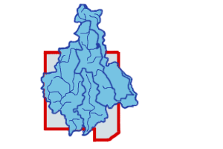

**Statement Regarding**

**Possible Conflicts of Interest**

In accordance with a resolution and Conflict of Interest Policy adopted by the Executive Board of the DuPage River Salt Creek Workgroup (DRSCW) on June 6, 2008, I hereby certify as follows:

1. Have you had any direct or indirect financial interest in any DRSCW matters in the past year?

□ Yes □ No

If you answered “Yes,” please explain:

1. Have you been the recipient of any payment, loan, gift, or discount from or on behalf of any person or organization which was directly or indirectly involved in any DRSCW matters in the past year?

□ Yes □ No

If you answered “Yes,” please explain:

I understand that the DRSCW Conflict of Interest Policy is meant to supplement good judgment and I will respect its spirit as well as its wording.

|  |  |
| --- | --- |
| Name of Executive Board member (please print) |  |
|  | |
|  | |

|  |  |  |  |
| --- | --- | --- | --- |
|  | | | |
| Signature |  | Date |  |