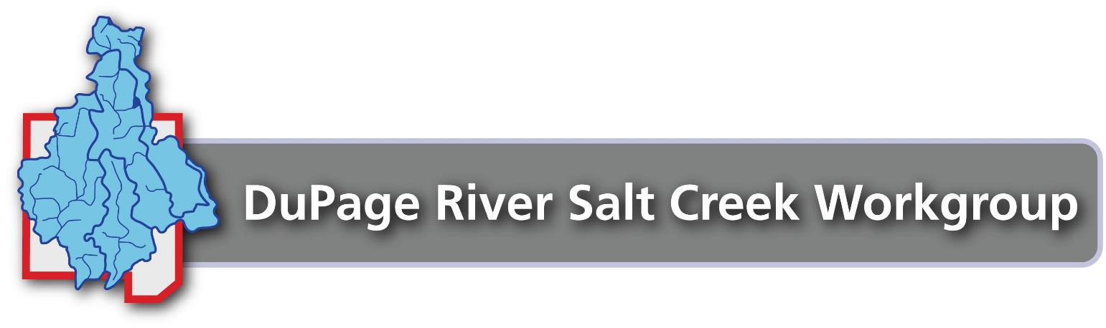

Model Facilities Plan for Snow
and Ice Control

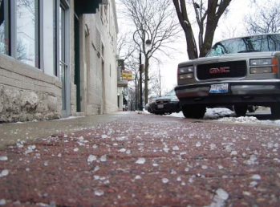

  - DuPage River Salt Creek Workgroup

October 8, 2015 – Version 1

Prepared by:

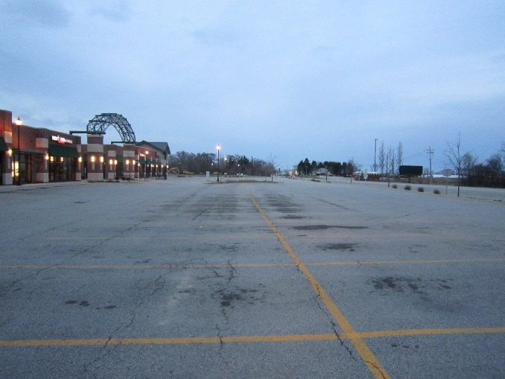

Guide to Use of this Model Facilities Plan
The DuPage River Salt Creek Workgroup (DRSCW) developed this Model Facilities Plan for Snow and Ice Control to aid facility managers in developing a plan for winter operations protocols for snow and ice control at their facilities. The plan is beneficial for facility management in several ways:
- Establishes and documents winter operations policy and operational protocols
- Documents program management and staff responsibilities
- Provides a program training resource for facility staff
- Provides a program overview for facility ownership/management board
- Explains the program’s extent and limitations to facility employees and the general visiting public
This model facilities plan has been developed for an example fictitious facility named “Facility” throughout. Each section contains an introductory statement in italics that explains the section’s content. Each section provides example content considered to reflect best management practices for snow and ice control, which should be used as a reference then tailored to your specific facility’s protocols, conditions, and practices. After deleting the italicized introductory statement in each section, then modifying the content to reflect your facility’s program and specific facility details, you will have created a thorough plan for snow and ice control at your facility.
The DRSCW created this model plan as part of its Chloride Education and Reduction Program. Winter snow and ice control operations have been determined to be significant sources of chloride loading to area waters (chloride from road salt, for example). The DRSCW provides training and resources for facility managers and staff on ways to provide essential facility services while using best management practices to reduce chloride usage. See DRSCW’s Chlorides and Winter Management webpage for program materials and more information: http://www.drscw.org/winter.html
The following resources were used to develop the Model Facilities Plan for Snow and Ice Control.
- DRSCW Webpage materials: http://www.drscw.org/winter.html
- Fortin Consulting Winter Maintenance Manual: Winter Parking Lot and Sidewalk Maintenance Manual, 2010
- DRSCW Study Report: http://www.drscw.org/chlorides/ChlorideRecomendations.Final_Report.pdf

Table of Contents
Section 1 Introduction 1-1
1.1 Facilities Plan for Snow and Ice Control 1-1
Section 2 Overall Policy Statement 2-1
2.1 Safety, Facility Impact, and Environmental Quality 2-1
2.2 Liability 2-1
Section 3 Management 3-1
3.1 Responsibilities 3-1
3.2 Contact Information 3-1
Section 4 Education and Training 4-1
4.1 Training 4-1
4.2 Worker Safety 4-1
Section 5 Equipment 5-1
5.1 Equipment Used for Snow and Ice Removal 5-1
5.2 Equipment Calibration 5-1
Section 6 Locations 6-1
Section 7 Event Implementation 7-1
7.1 Preseason Preparation 7-1
7.2 Ice Control 7-1
7.3 Motorized Equipment Deployment 7-2
7.4 Special Instructions 7-2
7.5 Event Follow-Up 7-3
7.6 Post Season Shutdown 7-3
Section 8 Products 8-1
8.1 Storage 8-1
Section 9 Weather Forecasting 9-1
Section 10 Application 10-1
10.1 Application Rates 10-1
10.2 Temperature Sensing 10-2
Section 11 Prioritization 11-1
11.1 Priority for Snow and Ice Control Operations 11-1
Section 12 Record Keeping 12-1
Section 13 Contact Information 13-1

Figures
Figure 6-1. Facility Map 6-1

Tables
Table 10-1. Deicing Application Rates 10-1

Introduction
This section provides an overview of the plan for your facility. It should be tailored for your specific facility information.
  - Facilities Plan for Snow and Ice Control
The Facilities Plan for Snow and Ice Control has been developed to describe Facility’s program to provide safe winter operating conditions throughout the facility. Depending on the response necessary for winter weather events, snow and ice control operations are provided by facility grounds maintenance staff and/or contracted staff for plowing and shoveling. This plan describes the resources, training, equipment, deicing agents, winter event implementation protocols, and communication protocols used throughout the winter season.

Overall Policy Statement
This section provides an example program policy statement. It should be modified for your facility’s program.
  - Safety, Facility Impact, and Environmental Quality
Facility has developed its Snow and Ice Control Program to provide for safe winter conditions for facility guests and employees. Facility provides these services in a manner protective of personal, public, and facility infrastructure. Facility staff responsible for implementing the program have been trained on the use of the equipment and materials necessary, and perform activities in a manner that minimizes the impact to the local environment to the extent practicable.
  - Liability
Facility implements its Snow and Ice Control Program to prevent or to minimize accidents and injuries related to snow and ice conditions throughout the facility. Facility implements the industry best management practices as described within this plan to provide for safe winter operational conditions.

Management
This section provides example program management roles and responsibilities. It should be modified to represent the management structure of your program.
  - Responsibilities
- The Facility Administrator is responsible for overall facility operational decisions. The Facility Administrator decides and informs of facility closures and reopening of facility operations during adverse storm conditions.
- The Director of Facilities Administration is responsible for the overall implementation of this plan, including:
- Annual review of plan and staff training
- Assessing plan performance and adjusting the plan as necessary
- Making recommendations regarding facility closure based upon police reports, national weather bureau forecasts, and existing conditions of Facility grounds. Recommendations are made by 5:20 am for daytime operations and 2:20 pm for evening operations
- The Director of Facilities Support Services is responsible for primary snow/ice removal efforts conducted by the building custodians and grounds maintenance work force, including employees on temporary duty assignments with this work force. The Director of Facilities Support Services is responsible for staff training, equipment readiness, deicing agent inventories and proper handling and storage, and the proper implementation of snow and ice removal procedures. The Director of Facilities Support Services is responsible for activating outside contractors to assist with Facility snow removal operations when needed.
- The Grounds Maintenance Manager assists the Director of Facilities Support Services in all snow and ice removal operations.
- Building Custodians, working under the direction of the Manager of Custodial Services, are responsible for clearing snow and ice from emergency exits and for the maintenance of all building steps and exit ways for at least 15 feet from each building.
- The Automotive Mechanic Supervisor is responsible for pre-winter servicing of all snow/ice removal equipment and direct support of grounds keeping efforts during storm conditions.
  - Contact Information
The Director of Facilities Support Services may be contacted for questions or additional information regarding this plan during normal business hours at 555-555-5555.

Education and Training
This section contains example program education and training elements. It should be modified to represent your training program.
  - Training
Snow and ice control training is provided on an annual basis. Snow and ice removal staff attends regional workshops for general training on effective protocols, best management practices, safety, and environmental protection. Facility specific training is provided by the Director of Facilities Support Services at the beginning of each winter season, with additional training provided after each winter event (post-event effectiveness debriefs).
- Staff that use commercial vehicles have a commercial driver’s license and are trained in both the use of the vehicle and snow and ice control protocols, including handling and use of deicing materials.
- Workers using non-commercial vehicles are trained on proper plowing techniques, installation and storage of snow chains, plow attachment, and plow usage.
- Both commercial and non-commercial drivers are trained to yield to pedestrians and vehicles during snow and ice removal and the proper accident response protocols.
- Workers using snow blowers are trained on the proper and safe use of the equipment.
- Workers involved in shoveling and hand deicing activities are trained for these activities and to take breaks at intervals to avoid overexertion, frost-bite, or other potential adverse health conditions.
- Workers are trained to remove snow and ice from steps, stairs and ramps, and on the proper amount of de-icing materials to be used.
- New hire employees are trained on proper use of equipment they will be operating.
- All employees are trained to report black ice/re-freezing or other unsafe Facility conditions to management as soon as possible for necessary response.
  - Worker Safety
Management uses sound judgment and does not expose workers to severe weather conditions such as extreme winds, freezing rain, severe temperatures, or blinding snow that could place workers at risk of injury.

Equipment
This section describes example snow and ice removal equipment. It should be modified to reflect the equipment used at your facility.
  - Equipment Used for Snow and Ice Removal
Equipment for both roadway/parking lot, and sidewalk/entranceway areas are maintained by Facility. The inventory is developed and maintained by the Director of Facilities Support Services.
An inventory of equipment is maintained at each building area as appropriate for the building area use. Inventory is replenished by November 15th of each year, including:
- Gloves, ice scrapers, shovels, brooms
- Snow blowers/bushes
- Liquid application sprayers
- Snow fencing and landscape fencing
- Snow markers (fire hydrants, sidewalks, abutments, driveways)
- Ladders and poles for the removal of icicles, which present a danger to pedestrians
An inventory of roadway/parking lot snow and ice removal equipment is maintained at the mechanical shop/yard. The inventory is developed and maintained by the Director of Facilities Support Services. Operations staff maintains, calibrates, and prepares the equipment for winter events. The equipment is readied by November 15th of each year, and includes:
- Snow plows/spreader trucks
- Liquid application trucks
  - Equipment Calibration
Salt and liquids spreading equipment is tested and calibrated on an annual basis, prior to November 15th each year. Any equipment spreading more or less product than desired is adjusted under the supervision of the Automotive Mechanical Supervisor.

Locations
This section provides example information on facility snow and ice removal locations. It should be modified for your specific facility.
Snow and ice removal occurs at all facility buildings, sidewalks, and entranceways. This includes emergency exits, loading docks, and other critical facility areas. Rooftops are cleared of snow and any accumulated icicles when determined necessary by the Grounds staff.
Snow and ice removal occurs at facility roadways and parking lots. This includes the front access drives, parking lot feeder drives, and maintenance and building services drives.
The map provided below (Figure 6-1) shows snow and ice removal areas, drainage areas, deicer storage, and equipment storage locations.
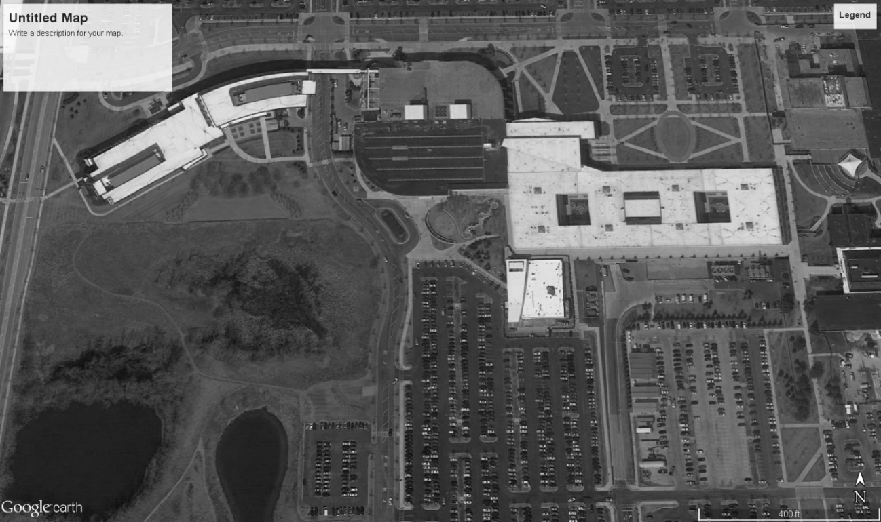
Deicer and Equipment Storage Area
Snow and Ice Removal Areas
Example Facility Map
Figure 6-1. Facility Map

Event Implementation
This section provides example winter event implementation protocols, and should be modified for your specific facility’s protocols.
There is no parking on either weekdays, weekends or holidays in Facility parking lots between the hours 2:00 am to 5:00 am from November 1st to April 1st. Any and all violators will be ticketed and possibly towed at the vehicle owner’s expense.
All questions, requests for services, comments, or complaint calls are directed to the Director of Facilities Support Services at 555-555-5555.
  - Preseason Preparation
- By no later than November 15th of each year:
- Snow markers are placed at each hydrant, drain opening, valve, or other necessary installations that could become buried with snow.
- Earth, gravel and stone surfaces are removed. Rocks, stockpiles, and other obstructions are removed from areas to be plowed.
- All culverts, drainage ditches, and storm drains are cleaned of obstructions to prevent water from ponding and freezing.
- The Grounds Maintenance Manager determines the need for snow and landscape fences, and provides for installation.
- Shoveling steps and areas inaccessible to equipment is accomplished by hand labor. Particular attention is paid to clearing handicap access areas, keeping storm drains free, and avoiding covering fire hydrants, valves, etc.
  - Ice Control
- At critical areas, such as handicap access ramps and entrances, deicer is applied at the beginning of the storm. The resulting slush is not deposited on grass or landscaped areas if possible.
- During and after snow removal operations, all practical measures are taken to provide free drainage for melting snow so that cleared surfaces do not become covered with water. This requires inspection each day that significant amounts of snow remain on the ground.
- Icicles are removed from above doors, porches, and pedestrian walkways by roofers, exercising extreme caution at all times to protect pedestrians.
- Frequent inspections during and after storms are made by the Grounds Maintenance Manager and Director of Facilities Support Services, and hazardous conditions are eliminated upon discovery or as promptly thereafter as possible.
  - Motorized Equipment Deployment
During snow and ice events (while precipitation is falling), the Grounds crew is called in to ensure that "one pass" on walks, roads, and drives can be accomplished. The Grounds crew helps conserve driver and equipment resources while precipitation is falling, recognizing that a full property-wide clean-up must follow.
The equipment used during storms is dependent upon the snow accumulation and is generally as follows:
- Accumulations less than 1 inch
- Snow blowers/brooms for walks, and plow/salter trucks for roadways are deployed by Grounds staff. The remaining Grounds crew members not operating blower/brooms are deployed to shovel stairs/curb cuts. Building maintenance staff assist with stair and entranceway shoveling.
- Accumulations greater than 1 inch
- Grounds staff deploy plow trucks/spreaders. Building maintenance staff continues shoveling sidewalks and entranceways.
After precipitation has stopped, the major primary clean-up effort begins. The equipment used is dependent upon the snow accumulation and occurs generally as follows:
- Accumulations less than 1 inch
- For accumulations less than 1 inch, clean-up deployment is the same as for the accumulations less than 1 inch above.
- Accumulations greater than 1 inch
- For accumulations greater than 1 inch, the entire Grounds crew, plus auxiliary drivers are called in. The Director of Facilities Support Services may activate contractual snow and ice removal assistance for larger events.
  - Special Instructions
- Once snow removal work shifts have begun, they automatically continue from day-to-day and week-to-week until ended by the Director of Facilities Support Services or Manager of Grounds Maintenance.
- During a protracted storm, the Grounds Maintenance Manager rotates personnel (including equipment operators) so they do not become fatigued. Warm-up times must be provided. Personnel are rotated so equipment can remain in operation continuously.
- During extended periods of snow removal operations, the Manager of Grounds Maintenance may reassign part of the crew to nighttime duty.
- Equipment operators have the flashing lights operating when engaged in plowing, salting, or cindering operations.
- Any equipment failures or breakdowns are reported immediately to the shift supervisor. The shift supervisor then documents the date, time, and nature of breakdown and reports to the Director of Facilities Support Services. Vehicular accidents are reported to Public Safety immediately.
- The Manager of Custodial Services or designee checks all entrances and exits.
- Care is exercised to ensure that lawn areas are not damaged by snow removal operations.
  - Event Follow-Up
- Maintenance is performed on all equipment after use or as needed during use.
- Supplies are replenished as necessary. In coordination with the Director of Facilities Support Services and upon request via a Facilities Work Request, contained/properly labeled ice melt products are delivered to replenish stocks at previously approved locations.
- A post-event debrief occurs between Grounds Maintenance Manager and the Director of Facilities Support Services, including any staff training for adjustments in protocol.
  - Post-Season Shutdown
As soon as practical after April 15th, but usually no later than April 30th, snow stakes, safety cones or other devices used during the winter season are removed by Grounds personnel at their normally assigned locations.
Deicing materials are inventoried and stored in a designated secure location. Bulk and bagged salt are stored neatly and in such a way so as to maintain the integrity of the product and protect the environment.
As soon as practical, the Mechanical Staff repairs snow equipment and readies the equipment for seasonal storage. Under no circumstances is equipment to be stored in a non-functional state unless deemed by the Grounds Maintenance Repair Facility Supervisor to be out of service, rendered unusable or if parts are temporarily unavailable.
The Director of Facilities Support Services secures and stores snow and ice removal equipment upon completion of repairs in a manner that protects the equipment from damage.

Products
This section describes example facility deicing products. It should be modified to reflect the products used at your facility.
Deicing products used at Facility throughout the winter season include:
- Solid rock salt (pre-wetted)
- Liquid calcium chloride
- Liquid beet juice/brine mixture
An adequate supply of salt and deicing liquids is obtained by the Director of Facilities Support Services prior to November 15th of each year. A ten-ton start-up inventory of pre-wetted rock salt usually supplies 80 percent of annual facility demand. Liquid storage is refilled and replenished as needed throughout the season. A replenishment supply of salt is ordered as needed to maintain a minimum inventory of 3 tons.
  - Storage
Salt and other products are stored on-site in such a way that the materials are not exposed to the elements and are away from storm drain inlets. Covered salt storage bins have been constructed on site to store salt. Liquid deicer is stored in tanks near the storage bins.
The salt and liquids storage area is located away from vehicular traffic and are marked for identification. Storage areas are inspected annually, both pre- and post-winter season, for integrity and need of repair.

Weather Forecasting
This section should be adjusted for your weather forecasting protocols.
Weather forecasting is used to plan snow and ice control operations and weather-related emergencies. The Director of Facilities Support Services utilizes a professional weather forecasting service during the winter season. The service provides the Director of Facilities Support Services with information that assists in determining what impact present and forthcoming weather will have on overall operations. Forecasting resources also provide on-screen tracking of weather systems and data for Facility’s region. The Director of Facilities Support Services also relies on information from the National Weather Service as it relates to snow and ice conditions in Facility’s county and surrounding regions of the state.

Application
This section provides guidance and example deicing application rates. It should be adjusted for your specific facility protocols.
  - Application Rates
Facility staff applies deicing agents on parking lots and sidewalks at the rates shown in the following table.
Table 10-1. Deicing Application Rates
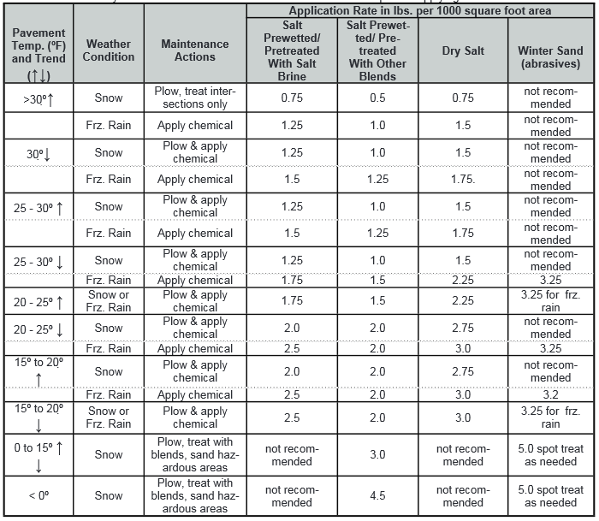
Fortin Consulting, 2010
Grounds maintenance staff apply deicing agents to Facility’s roadways generally at the following application rates:
- Solid rock salt (pre-wetted) – 120 lbs./lane mile
- Liquid calcium chloride – 30 gal./lane mile
- Liquid beet juice/brine mixture – 40 gal./lane mile
Application rates vary depending upon pavement temperature and other weather conditions.
  - Temperature Sensing
Temperature sensing equipment is used in collaboration with weather forecasting to aid in determining snow removal and/or deicer selection and application. The Director of Facilities Support Services has a handheld pavement temperature sensor that is used prior to winter events, and during longer duration events to adjust deicing application products and application for optimal effectiveness.

Prioritization
This section describes example implementation area prioritization. It should be modified for your facility and protocols.
  - Priority for Snow and Ice Control Operations
In order to make the most efficient use of available resources, Facility has established implementation area priorities using the assumption that the severity of a storm does not exceed the capabilities of the snow removal operations of the Facilities Support Services department. Depending on the nature of any given snow storm, deviations, and/or contingency plans could occur.
The priority areas are as follows, in order of priority:
- Fire exits of all buildings, fire hydrants and handicap ramps, curb cuts, and entrances
- Access roads and fire lanes for emergency vehicles
- Sidewalks and steps
- Parking lots
- Service access roads/lanes
Snow removal area priorities may be adjusted by the Director of Facilities Support Services, depending on weather conditions, time of day, day of the week, and scheduled Facility events.

Record Keeping
This section describes example record keeping protocols. It should be modified for your record keeping protocols.
The Director of Facilities Support Services maintains the following records for plan implementation.
- Staff training records
- Equipment inventory, maintenance and calibration records
- Salt and deicing agent purchase, inventory and usage records
- Service request/complaint call records
Staff training records are kept to record staff that have received training, the training topics, and frequency of training. Both facility and outside agency trainings are provided and recorded.
Equipment inventory, maintenance and calibration records are kept for warranty and service purposes, and track the calibration and performance of individual pieces of equipment.
Salt and deicing agent purchase, inventory and usage records are kept to track purchase quantities and benchmark event and annual usage by facility staff. Application rates are tracked to optimize material usage with respect to facility safety, cost control, and environmental protection.
Service requests and complaint calls are tracked to monitor plan implementation, facility prioritization, and to make adjustments as needed.

Contact Information
This section provides example facility contact information and should be modified for your specific organization.
For further information on the content and implementation of this plan, contact the Director of Facilities Support Services at 555-555-5555.

